CN Lab # 13
21F-9136
Ayesha Zahid
Section 6E
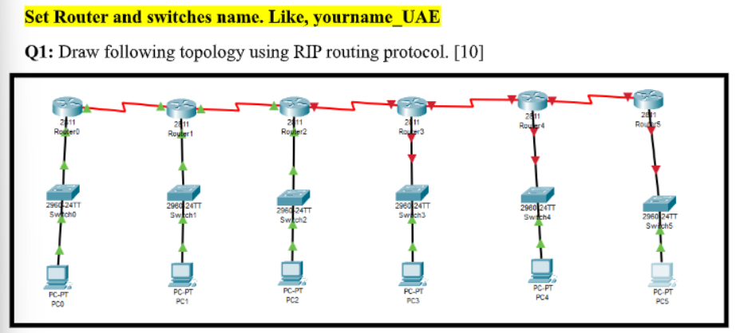

First => off the switch put wic-2T in the box on the switch and perform this on all the routers

Before putting
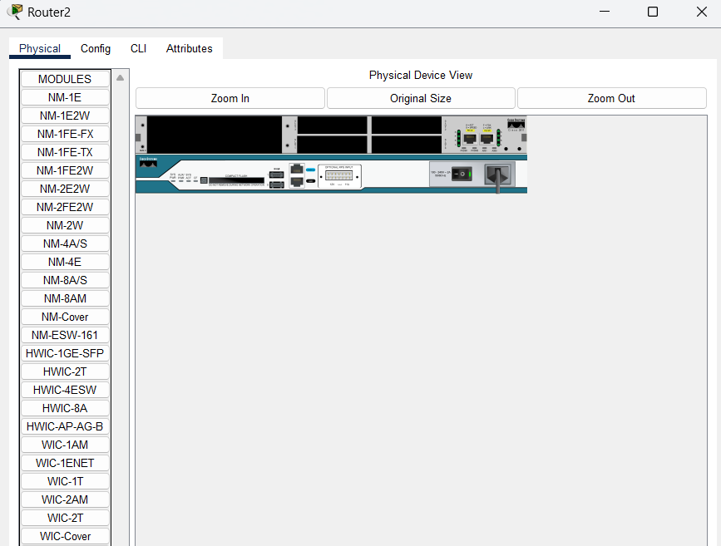

and switch off
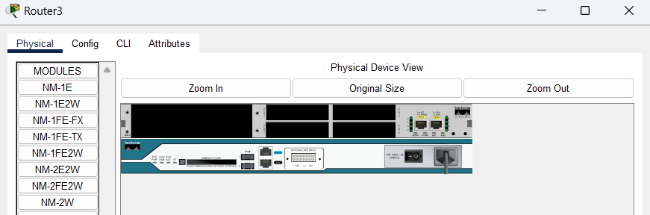

After putting and switch on
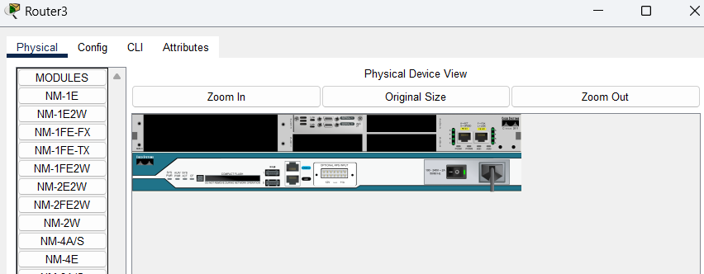

2nd => connect routers with serial dce
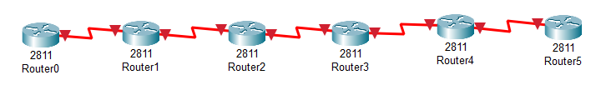
3rd => connect routers with switch -> switch with pc
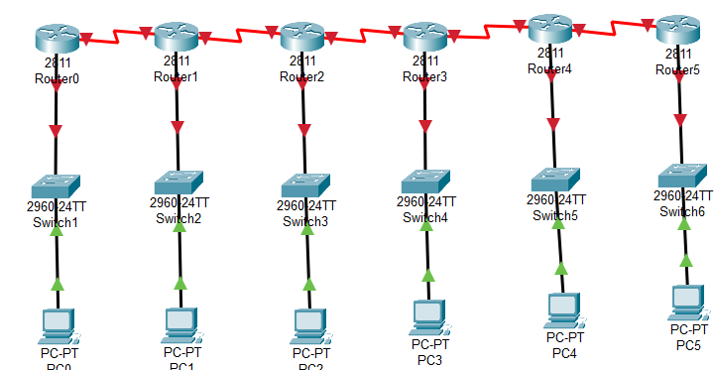

4th => change the name of all the routers and switches
Router 1) Ayesha_uae
Router 2) Ayesha_pak
Router 3) Ayesha_japan
Router 4) Ayesha_korea
Router 5) Ayesha_isb
Router 6) Ayesha_swat
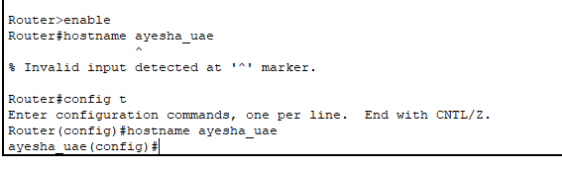
Switches ->
s-1) Ayesha_uae
s-2) Ayesha_pak
s-3) Ayesha_japan
s-4) Ayesha_korea
s-5) Ayesha_isb
s-6) Ayesha_swat
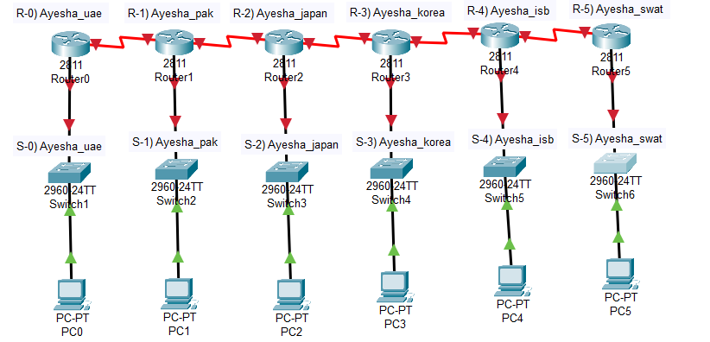

Going in interface of all the routers
Router 0)
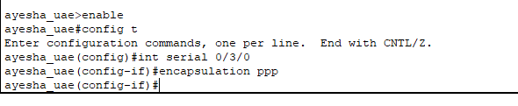
Router 0)
Assigning bandwidth and ip
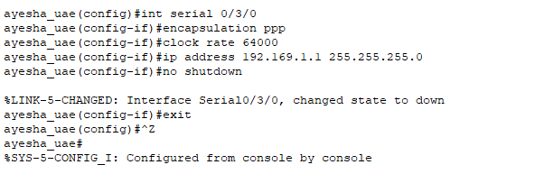
Router 1)
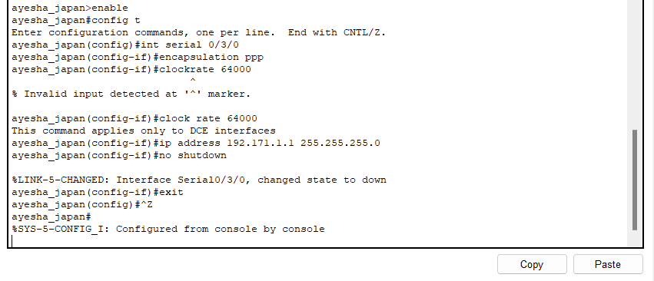

Router 1)
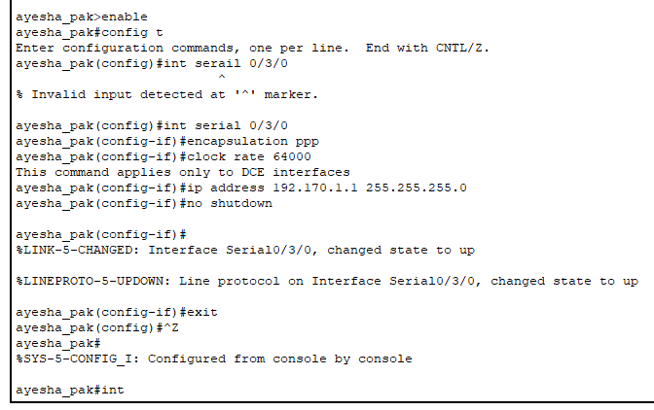
Router 2)
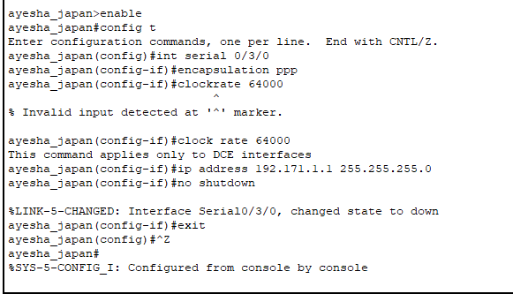

5th =>Assigning networks whole network id

Pc-1
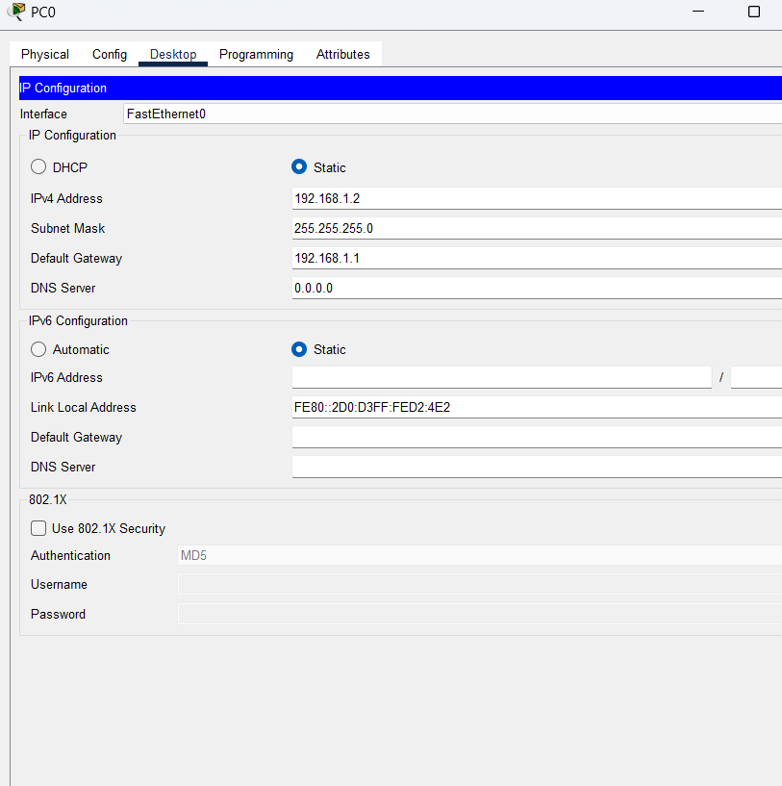

Router 1)

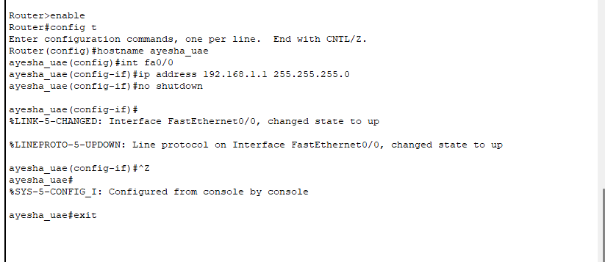

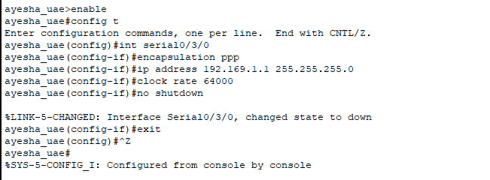

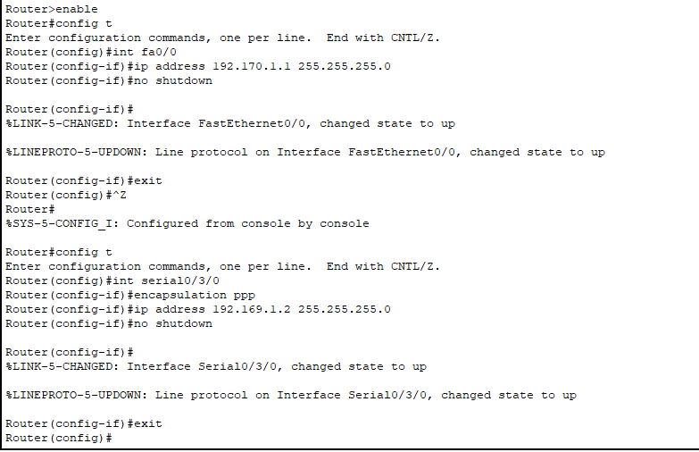

6th => Assigning Router’s other Network Id’s
Router 1)

Router 2)

Router 3)

Final topology
